

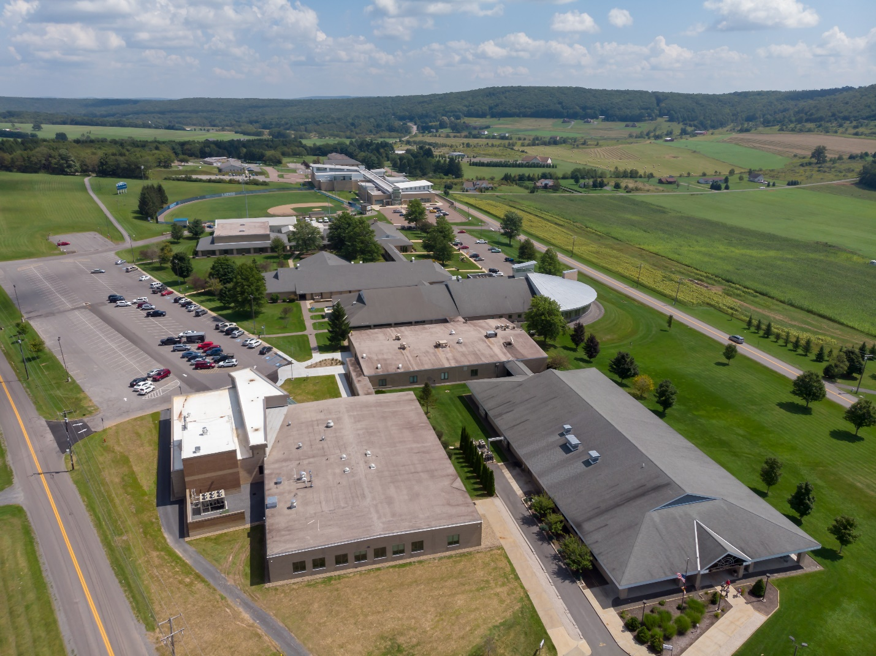

**FACILITIES MASTER PLAN 2012-2022**

**Supplement Issued January 2016**

**Update**

**February 1, 2019**

**TABLE OF CONTENTS**

**I. Updated Executive Summary 1**

**II. Update of Enrollment Trends 4**

**III. New Buildings 7**

**IV. Prioritization of Proposals 9**

**V. Implementation of Plan 9**

**attachments 12**

Attachment A - Mission, Vision, Values and Institutional Goals

Attachment B - Garrett College 2018 CC Tables

Attachment C – Facilities Renewal Plan

**I. Updated Executive Summary**

Garrett College submitted a 10-Year Facilities Master Plan in January 2012 and a subsequent Facilities Master Plan Supplement in February 2016. This 2019 Update has minimal changes with respect to the projects for which we are requesting state funding. Only the proposed funding request years are being updated. There are also changes with respect to projects in the investigation stage.

In the year-and-a-half following the February 2016 Supplement submittal, the top three positions at Garrett College (President, Vice President of Academic Affairs, and Vice President of Administrative and Financial Services) were filled by new personnel. President Richard MacLennan resigned June 2016, Interim President Al Coviello served for 6 months, and current President Richard Midcap began in January 2017. The Vice President of Academic Affairs position was restructured to become the Dean of Academic Affairs/Chief Academic Officer.

Under this new leadership, the College’s mission, vision, and values (MVV) statements, and strategic goals, were reviewed and updated through a process involving nearly all of the College’s faculty, staff, and administrators. The FY 2017-2020 Strategic Plan, originally approved by the Garrett College Board of Trustees in November 2016, was most recently revised in September 2018 after the MVV review. The Academic Plan, written in 2012, was also recently reviewed and updated and is being submitted to the Board of Trustees this month.

In addition to these changes in our leadership, MVV statements, and Academic Plan, a change to the funding mechanism of one of our projects (the renovation of our old gymnasium into a Community Education and Performing Arts Center) occurred in the spring of 2018, which made it possible for us to now accurately update our Facilities Master Plan (FMP) projects list and to project our funding request years for future projects. Even with these recent changes, the necessary updates to Garrett College’s FMP are relatively minor. The 2012 10-Year FMP was primarily based on the need for renovations throughout the campus, and this basis still holds true and is strengthened by the recent changes at the College.

In 2011 Garrett College requested a facilities assessment from Grimm & Parker Architects for Buildings 200 through 800 and 1000. The report included descriptions, assessments, and recommendations relating to construction, ADA compliance, capacity for expansion, building envelope, HVAC, plumbing, fire protection, electrical, voice/data/video, and security. The overall common theme of the assessment was that many of our campus buildings were in need of renovation. In particular, Buildings 200, 400, 600, 700, and 800 were in serious need of major renovation.

Not only did Grimm & Parker’s assessment find the existing college facilities in serious need of renovations, but this was also the conclusion of the broad-based team formed to develop the 2012 10-Year FMP. The team (consisting of students, staff, faculty, community members, local elected officials, businesses, and local industry representatives) was in agreement that comprehensive building renovations are required in order to meet the College’s (past and present) mission, Strategic Plan and Academic Plan goals. The College must substantially improve the quality of its instructional and learning spaces to provide accessible, quality education in a supportive environment to better serve its student population.

The Academic Plan, in agreement with Grimm & Parker and the FMP development team, also states “much of the College’s instructional space [is] unattractive and poorly suited for its intended function, and therefore, not conducive to learning.”  Our Academic Plan also points out that, according to our 2018 CC Tables, the College has ample instruction space. “It is clear that for the foreseeable future (i.e. the next 5-10 years), the potential for further enrollment growth will *not* be limited by the availability of instructional space.”  This allows us to keep our FMP focus on renovating buildings that are “not conducive to learning” as well as address mechanical, electrical, plumbing, and fire protection infrastructure that is inadequate and inefficient.

In 2017-2018, some of this space was addressed through the Community College Capital Improvement Program (CCCIP) and smaller in-house projects.  With funds from the CCCIP, the College was able to renovate the 200 Building into a new STEM educational facility. In addition to this capital project, other spaces were renovated without state funding to accommodate the needs displaced by the 200 Building renovation, including Continuing Education and Workforce Development Offices, President’s Office, and Board Room. Much-needed classroom renovations and a new Cyber Security wing were also completed in the 100 and 300 buildings.

While the College has excess capacity with regard to classroom space, we showed a deficiency in tutoring and assembly spaces. To address this, additional tutoring spaces were created by consolidating and repurposing space in the library that was no longer needed for books (due to increased reliance on online resources). The College’s lack of adequate assembly space is being addressed through the planned Community Education and Performing Arts Center (CEPAC). This project, which involves renovation and expansion of the 800 Building (old gymnasium), is currently in the design stage and will be funded through the CCCIP, the Governor’s Miscellaneous Fund, and local funding.

After the CEPAC project, renovations of Buildings 400, 600, and 700 are planned and funds are being requested through the CCCIP. There are also various smaller projects being explored by the College, but these are not currently presented for funding through MHEC Community College channels. The College also has a 5-year Deferred Maintenance Plan that we plan to fund partially through the Facilities Renewal Grant. This plan has been updated since the eight colleges to receive funding in FY20 were selected. Garrett College was not one of these colleges, so we hope to receive funding in FY21. See Attachment C.

The Garrett College 2012-2022 Facilities Master Plan, the 2016 Supplement, and this 2019 Update all propose and plan for the renovations of five buildings. The order of the renovations has changed since 2012, but the need for the renovations to support the Academic and Strategic Plans has not changed.

The proposed order of the projects is:

* STEM Center, Renovation of and Addition to the 200 Building – *Completed Fall 2018*
* Community Education and Performing Arts Center, Renovation of and Addition to the 800 Building – Design began September 2018
* Learning Center, Renovation of the 600 Building
* Student Center, Renovation of and Addition to the 400 Building
* Administration & Student Services Building, Renovation of the 700 Building

Other projects currently being researched by the College:

* Increased parking
* Convert existing baseball field to turf that will also accommodate a softball field and possibly a soccer field
* An addition to the Center for Adventure and Outdoor studies (CAOS) to accommodate climbing wall, bouldering space and a high element challenge course.
* A Biomass Plant using wood chips to offset about 80% of the fuel oil and propane currently used for heating the campus.

|  |  |  |  |  |
| --- | --- | --- | --- | --- |
| **Proposed Projects** | **Fiscal Year** | **Estimated Project Cost ($000’s)** | **State Share ($000’s)** | **Local Share ($000’s)** |
| 1. **Building 200**   **STEM Center** | **Completed Fall 2018** | **8,526** | **4,263** | **4,263** |
| 1. **Building 800**   **Community Education & Performing Arts Center1** | **19** | **15,470** | **11,6851** | **3,785** |
| 1. **Building 600**   **Shaw Learning Center** | **22** | **7,126** | **3,563** | **3,563** |
| 1. **Building 400**   **Student Center** | **23** | **4,260** | **2,130** | **2,130** |
| 1. **Building 700 Administration and Student Services** | **24** | **4,578** | **2,289** | **2,289** |
| 1. **Parking Lot Expansions**2 | **21** | **286** | **-** | **286** |
| 1. **Turf Fields2** | **21** | **2,000** | **-** | **2,000** |
| 1. **Center for Adventure and Outdoor Studies Addition2** | **22** | **1,273** | **-** | **1,273** |
| 1. **Biomass Plant2** | **23** | **2,558** | **-** | **2,558** |

1 Funding approved by DBM through the CCCIP and the Governor’s Miscellaneous Fund.

2 State funding not being requested at this time.

**II. Update of Enrollment Trends**

*Student Characteristics & Demographics*

Student demographics are shown in the following table. For the fall 2018 Semester, the majority of the student population was between the ages of 18-24 (442 students); 52% were women; 77% of the student population was white; 17% of the student population was African-American; and the remaining 6% of the student population was Non-US Citizens, Hispanic, Asian, American Indian, or 2 or more races. Whereas the total number of students dropped from 673 (fall 2017) to 658 (fall 2018), the overall trend of enrollment at the College was enrollment growth to 2011 and then a gradual decrease in the following years with fall 2016 being an anomaly with enrollment of 754.

| ***Demographic Profile of Fall Credit Students, Fall Semesters, 2005-2014*** | | | | | | | | | | | | | | |
| --- | --- | --- | --- | --- | --- | --- | --- | --- | --- | --- | --- | --- | --- | --- |
|  | **05** | **06** | **07** | **08** | **09** | **10** | **11** | **12** | **13** | **14** | **15** | **16** | **17** | **18** |
| ***Female*** | *345* | *369* | *378* | *396* | *469* | *467* | *488* | *452* | *367* | *359* | *373* | *382* | *336* | *343* |
| ***Male*** | *302* | *365* | *399* | *434* | *428* | *383* | *414* | *421* | *402* | *354* | *339* | *372* | *337* | *325* |
|  |  |  |  |  |  |  |  |  |  |  |  |  |  |  |
| ***Under 18*** | *43* | *85* | *85* | *72* | *56* | *43* | *50* | *28* | *32* | *37* | *67* | *179* | *139* | *141* |
| ***18 – 19*** | *231* | *285* | *358* | *394* | *408* | *398* | *446* | *431* | *371* | *362* | *334* | *332* | *327* | *293* |
| ***20 – 24*** | *193* | *182* | *183* | *223* | *240* | *246* | *227* | *248* | *247* | *212* | *209* | *155* | *138* | *152* |
| ***25 – 29*** | *54* | *61* | *50* | *48* | *51* | *53* | *60* | *46* | *38* | *32* | *43* | *39* | *23* | *34* |
| ***30 – 39*** | *62* | *58* | *45* | *47* | *75* | *65* | *64* | *58* | *43* | *46* | *30* | *32* | *27* | *19* |
| ***40— 49*** | *46* | *42* | *36* | *30* | *47* | *25* | *36* | *37* | *19* | *14* | *17* | *13* | *12* | *10* |
| ***50 – 59*** | *11* | *18* | *13* | *15* | *17* | *16* | *15* | *21* | *14* | *6* | *10* | *3* | *6* | *6* |
| ***60 and older*** | *7* | *3* | *7* | *1* | *3* | *4* | *4* | *4* | *5* | *4* | *2* | *1* | *1* | *3* |
| ***Unknown age*** | *0* | *0* | *0* | *0* | *0* | *0* | *0* | *0* | *0* | *0* | *0* | *0* | *0* | *0* |
|  |  |  |  |  |  |  |  |  |  |  |  |  |  |  |
| ***White*** | *566* | *656* | *688* | *689* | *730* | *690* | *706* | *652* | *540* | *484* | *494* | *522* | *495* | *508* |
| ***African-Amer.*** | *45* | *34* | *51* | *94* | *127* | *132* | *165* | *180* | *168* | *171* | *168* | *189* | *141* | *112* |
| ***Hispanic*** | *7* | *8* | *11* | *18* | *12* | *7* | *12* | *14* | *21* | *18* | *12* | *11* | *12* | *12* |
| ***Asian-Pac. Isl.*** | *0* | *3* | *3* | *4* | *5* | *6* | *3* | *2* | *0* | *2* | *2* | *0* | *0* | *2* |
| ***Native Amer.*** | *2* | *5* | *2* | *3* | *3* | *1* | *2* | *2* | *2* | *1* | *2* | *2* | *1* | *4* |
| ***Native Hawaiian*** |  |  |  |  |  |  |  |  |  |  | *0* | *0* | *1* | *0* |
| ***Mixed/other*** | *25* | *28* | *21* | *22* | *20* | *14* | *14* | *23* | *27* | *37* | *23* | *18* | *14* | *9* |
| ***Unknown race*** | *2* | *0* | *1* | *0* | *0* | *0* | *0* | *0* | *11* | *0* | *1* | *2* | *0* | *0* |
| ***IPEDS Nonresident Alien*** |  |  |  |  |  |  |  |  |  |  | *10* | *10* | *9* | *11* |
| ***Total students***  ***(Headcount)*** | *647* | *734* | *777* | *830* | *897* | *850* | *902* | *873* | *769* | *713* | *712* | *754* | *673* | *658* |

As seen in the next table, 30% of the Garrett County High School Graduates (GCHSG) enrolled at Garrett College after graduation. The number of GCHSG began increasing in the fall 2007 semester and declined beginning in 2012. The increase is attributed to the implementation of the Garrett County Scholarship Program by the Garrett County Commissioners. The program is County funded and the Garrett County Scholarship Program provides all eligible Garrett County high school graduates equal access to post-secondary education and an equal opportunity for advancement. The goal of this program is to encourage Garrett County high school graduates to participate in post-secondary education and training as a means of improving their earning power and quality of life. The immediate objective is to encourage high school graduates to pursue post-secondary educational opportunities by making an education affordable. Subsequent phases of the program now allow high school graduates to participate in certificate training aimed at developing trade and vocational skills.

The decline is related to the overall decline in the Garrett County High school population.

|  |  |  |  |  |  |  |  |  |  |  |  |  |  |
| --- | --- | --- | --- | --- | --- | --- | --- | --- | --- | --- | --- | --- | --- |
| **Enrollment Rate of Garrett County High School Graduates, Fall 2006-2018**  **(Unduplicated Headcount)** | | | | | | | | | | | | | |
|  | **2006** | **2007** | **2008** | **2009** | **2010** | **2011** | **2012** | **2013** | **2014** | **2015** | **2016** | **2017** | **2018** |
| **GCHS grads** | 288 | 332 | 328 | 364 | 330 | 353 | 318 | 302 | 307 | 247 | 275 | 269 | 266 |
| **Enrolled GC** | 104 | 112 | 133 | 147 | 121 | 155 | 127 | 109 | 100 | 83 | 87 | 82 | 81 |
| **Enroll Rate** | 36% | 34% | 41% | 40% | 37% | 44% | 40% | 36% | 33% | 33% | 32% | 31% | 30% |

As seen below, the number of full-time students at the College has declined since 2012 and part-time students have followed the same pattern.

|  |  |  |  |  |  |  |  |  |  |  |  |  |  |
| --- | --- | --- | --- | --- | --- | --- | --- | --- | --- | --- | --- | --- | --- |
| **Course load of Fall Credit Students, Fall Semesters, 2006-2018** | | | | | | | | | | | | | |
|  | **2006** | **2007** | **2008** | **2009** | **2010** | **2011** | **2012** | **2013** | **2014** | **2015** | **2016** | **2017** | **2018** |
| **Full-time** | 450 | 543 | 584 | 653 | 647 | 706 | 686 | 597 | 577 | 549 | 523 | 472 | 421 |
| **Part-time** | 284 | 234 | 246 | 244 | 203 | 195 | 188 | 173 | 136 | 163 | 231 | 201 | 237 |
| **Total students** | 734 | 777 | 830 | 897 | 850 | 901 | 874 | 770 | 713 | 712 | 754 | 673 | 658 |

*Enrollment Trends*

Annual Unduplicated Headcounts for Credit class enrollment show initially a growth trend followed by a reduction, while enrollment trends for Annual Unduplicated Headcounts for Non-Credit classes began to increase in FY 2015.

|  |  |  |  |  |  |  |  |  |  |
| --- | --- | --- | --- | --- | --- | --- | --- | --- | --- |
| **Annual Unduplicated Headcount** | | | | | | | | | |
|  | **FY 2010** | **FY 2011** | **FY 2012** | **FY 2013** | **FY 2014** | **FY 2015** | **FY2016** | **FY2017** | **FY2018** |
| **Credit** | 1095 | 999 | 1069 | 995 | 905 | 826 | 901 | 908 | 835 |
| **Non-Credit** | 3705 | 3932 | 4514 | 4020 | 4000 | 4766 | 4701 | 4386 | 4801 |

*(Numbers are from “Unduplicated Headcount from RGENRL” report in Campus Café & Jenzabar as of FY16)*

As seen below, Garrett College experienced a record number of enrollments for the fall 2011-2012 Academic Year (AY), i.e., 902 headcount. The table also shows an enrollment decrease from the fall to the spring semesters, e.g., the fall AY2014-2015 enrollment of 713 students dropped in the spring AY2014-2015 to 610 students.

*(Numbers are from EIS files)*

As seen below, Garrett College’s Continuing Education Registrations totaled 15,774 in FY 2014.  The overall trend has been an increase in registrations since 2011; this is due to the expansion of the Garrett County Commissioners Scholarship and an increase in Workforce Programs on Campus.

|  |  |  |  |  |  |  |  |  |
| --- | --- | --- | --- | --- | --- | --- | --- | --- |
| **Continuing Education (Annual Course Enrollments)** | **2011** | **2012** | **2013** | **2014** | **2015** | **2016** | **2017** | **2018** |
| **Basic Skills and Literacy** | **260** | **277** | **260** | **122** | **129** | **239** | **208** | **154** |
| **Workforce Development** | **6159** | **7352** | **7022** | **7419** | **11389** | **11314** | **8801** | **8774** |
| **Community Service and Lifelong Learning** | **1093** | **2070** | **1532** | **1346** | **1763** | **1673** | **1617** | **1456** |
| **Professional Education leading to Industry Certificate** | **1043** | **998** | **996** | **1159** | **1579** | **1991** | **1021** | **828** |
| **Enrollment in Contract Training Courses** | **4269** | **5585** | **5534** | **5728** | **9549** | **8081** | **7014** | **6767** |
| **Total enrollments \*** | **7624** | **9830** | **8923** | **8937** | **13338** | **12214** | **10626** | **10383** |

* Some courses may be included in more than one of the above categories (i.e. one course may count in both Workforce Development and Professional Education Leading to Industry Certificate.)

“Total enrollments” does not count these duplications.

**III. New Buildings opened during the FY 2012-2022 Facilities Master Plan Period**

1. In the fall of 2012, the Community Aquatic and Recreation Center Gymnasium opened. Details included in the FMP 2016 Supplement, Section III.
2. In the fall of 2018, the Science, Technology, Engineering, & Mathematics (STEM) Center opened.

Programming:                   Academic: Classrooms, Labs, Offices, Meeting & Study Spaces

Condition Code:                New

Adequacy of Space:         Good

Sprinkler System:              Yes

Renovations:                     15,000 SF Renovation, 6,526 SF New Construction

Description:

Building 200, originally built in 1979 as a mining technology center, was renovated with an addition in 2017-18. The new STEM (Science, Technology, Engineering, and Mathematics) Center opened for the fall semester of 2018 as an academic building containing 4 classrooms, 4 labs (biology, chemistry/microbiology, engineering/robotics, and physical science/earth science) with associated preparation and work areas, 7 faculty offices, meeting rooms, storage areas, and student study and breakout areas. All mechanical, electrical, plumbing, and fire protection systems were replaced in compliance will all applicable building codes.

The total cost of the building was $8,526,000 including Architectural & Engineering Services, Construction, Furniture & Equipment. Funding for the building was provided through the CCCIP, the Garrett County Government, and the Appalachian Regional Commission. The building consists of 21,526 GSF and 13,672 NASF for an efficiency of 64%. All building components are ADA accessible.

*Pictures*

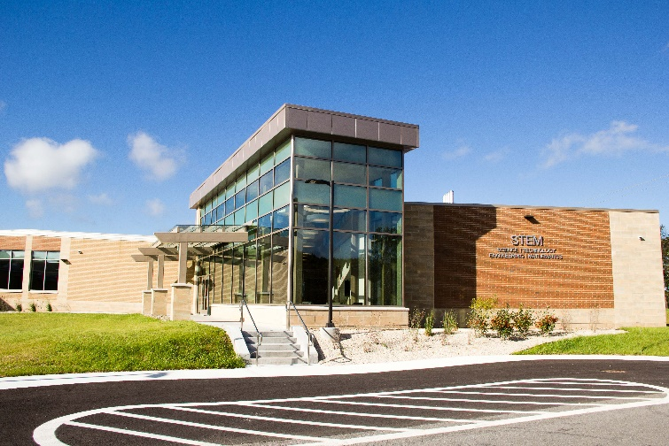  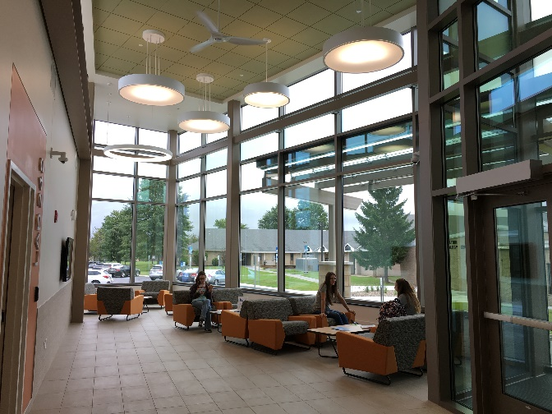

Main Entrance

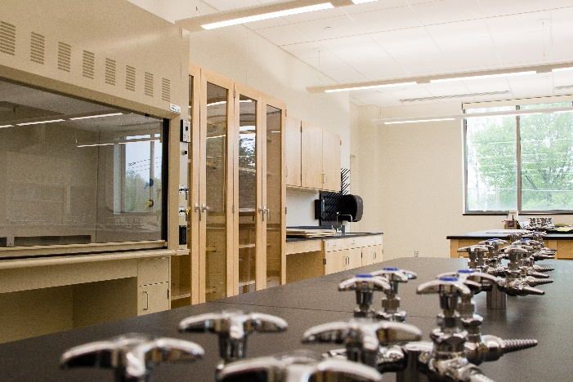 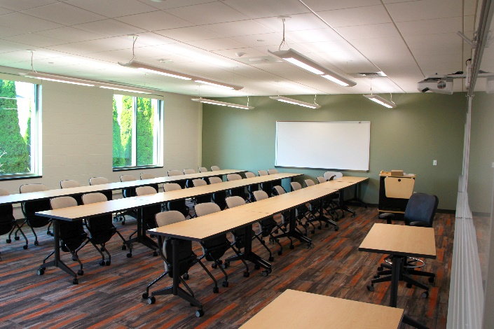

Chemistry/Microbiology Lab Classroom

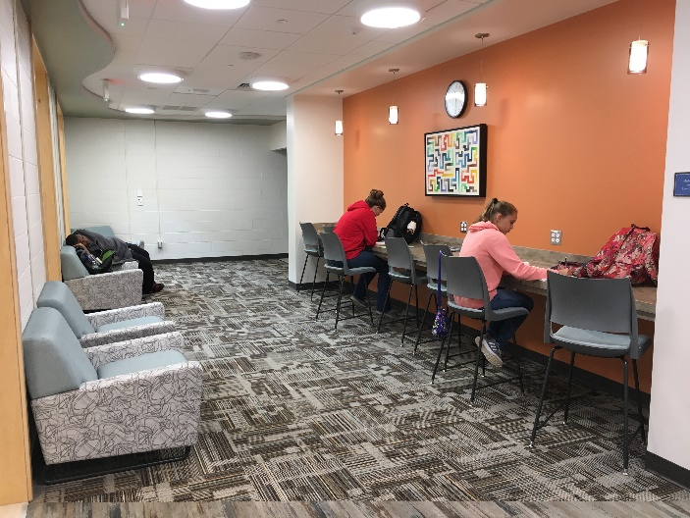 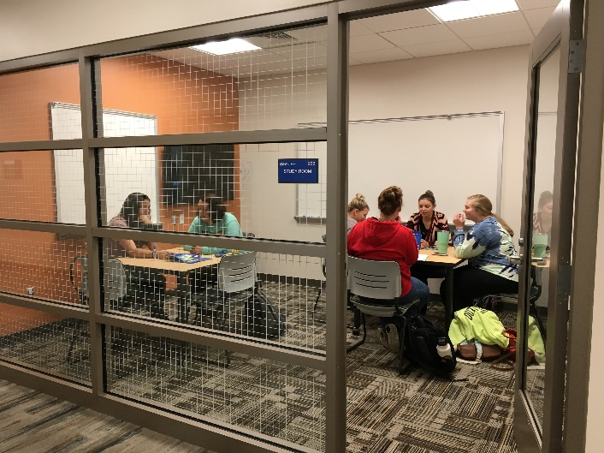

Student Break and Study Areas

*Floor Plan*

**

**IV. Prioritization of Proposals**

There is no change in prioritization for the 5 renovation projects for which state funds are being requested (projects 1-5). The Parking Lot expansion project has moved up in priority so that its timing can coincide with the construction of the CEPAC Project. The Biomass Plant has dropped in priority due to the workload associated with the necessary research to evaluate the project.

The prioritization table of projects is as follows:

|  |  |  |
| --- | --- | --- |
| **Project Priority** | | **Fiscal Year** |
| 1 | **Building 200 STEM Center** | Completed Fall 18 |
| 2 | **Building 800 Community Education & Performing Arts Center** | 19 |
| 3 | **Building 600 Shaw Learning Center** | 22 |
| 4 | **Building 400 Student Center** | 23 |
| 5 | **Building 700 Administration and Student Services** | 24 |
| 6 | **Parking Lot Expansions** | 21 |
| 7 | **Turf Fields** | 21 |
| 8 | **Center for Adventure and Outdoor Studies Addition** | 22 |
| 9 | **Biomass Plant** | 23 |

**V. Implementation of Plan**

**State and County funding are requested for the following projects 1-5.**

1. Building 200 STEM Renovation and Addition *\*Complete Fall 2018*

Building 200 was renovated and an addition built. The new STEM Center opened for students, faculty, and staff for the fall 2018 semester. Design and construction took 2 years. Funding was provided by the CCCIP, Garrett County Government, and the Appalachian Regional Commission.

1. Building 800 Community Education and Performing Arts Center Renovation and Addition

Building 800, the College’s old gymnasium, will be renovated into the new Community Education and Performing Arts Center. The building will include a 450-seat theater with all associated back-of-house spaces, a multipurpose room for meetings, conferences, rehearsals, and recitals, faculty offices, a catering kitchen, and all new mechanical, electrical, plumbing, and fire protection infrastructure.

After having local and state funding approved for this project for FY17, our local funding was rescinded and the future of the project was uncertain. In the spring of 2018, funding for the project was included in the Governor’s FY19 Capital Budget under Miscellaneous Grants at 75% funding, and Garrett County government agreed to provide the remaining 25%.

The Architectural and Engineering Services went out for bid in May 2018, and the project is currently in the design phase. Construction is scheduled to begin in 2020 with anticipated completion fall 2021.

1. Building 600 Shaw Learning Center Renovation

Building 600 is one of the College’s three original buildings. It originally housed the library, but after the new library was built in 2006, an in-house renovation was done to utilize the vacated area for temporary office space. In 2018, three science labs were relocated from this building to the new STEM Center, leaving behind the 1970s chemistry, biology, and physics labs cabinetry and equipment. This building will be renovated as the primary academic building. If surge space cannot be coordinated outside of this building, a staged construction schedule can be utilized.

Part I and Part II for this project will be developed in 2021. This project is included in MHEC’s Form B, and state and county funding will be requested for 2021.

1. Building 400 Student Center Renovation

Building 400 will be renovated to include a modern food facility and student center. The plan includes an addition to the north end of the building. The existing kitchen was built in 1981 as academic space for a Hotel and Restaurant Management program, but it is now being used a Café kitchen to service the student population including those who live in campus housing and rely on the Café for their dining services. However, the kitchen lacks the necessary equipment to efficiently service the students. The current dining hall only seats 80 students. The new center will include a kitchen, larger dining hall, bookstore, and security offices. College departments that are currently located in the building (Financial Aid, Enrollment, Admissions) will be relocated to Building 700 to be joined with the Business Offices.

Part I and Part II for this project will be developed in 2022. This project is included in MHEC’s Form B, and state and county funding will be requested for 2022.

1. Building 700 Administration and Student Services Renovation

Building 700, one of the three original buildings on campus, will be renovated for offices and converted to an administration and student services building that will house student services, including financial aid, registration, business office, and admissions. The areas in this building that are currently used by the theatre and music departments will be relocated to the 800 Building upon completion of the CEPAC project in 2020.

Part I and Part II for this project will be developed in 2023. This project is included in MHEC’s Form B, and state and county funding will be requested for 2023.

**The following projects 6-10 are not requesting State and County funding at this time.**

1. Turf Athletic Fields

The original 2012 Master Plan called to move the baseball field to the eastern-most part of campus and replace it with a soccer field. The 2016 Supplement changed these plans to leave the baseball field in its current location and place a soccer field and a girls’ softball field on the eastern-most part of the campus.

Garrett College is now investigating the option of installing turf on the existing baseball field which will also provide for a softball field, and possibly a soccer field.

State funding is not being sought for this project at this time. The cost of this project is approximately $2,000,000.

1. Parking Lot Expansions

As indicated in the 2018 CC Tables (Attachment B), the college has adequate parking and handicap parking to meet its current needs. However, the college will conduct an evaluation of parking needs with relation to the new Community Education and Performing Arts Center.

State funding is not being requested at this time.

1. Center for Adventure and Outdoor Studies Addition

A new facility for the Center for Adventure and Outdoor Studies was proposed in the 2016 FMP Supplement. No new development has been made for this project, and it remains on our project list for future investigation. Details for this project were included in the 2016 Supplement, attachment C.

State funding is not being requested at this time.

1. Biomass Plant

The 2016 FMP Supplement included information for a proposal to build a Biomass Plant on campus. No new development has been made for this project, and it remains on our project list for future investigation.

State funding is not being requested at this time.

Two-Generation Program Day Care Facility

This project was not funded as expected through Garrett County Community Action and as a result was removed from the FMP.

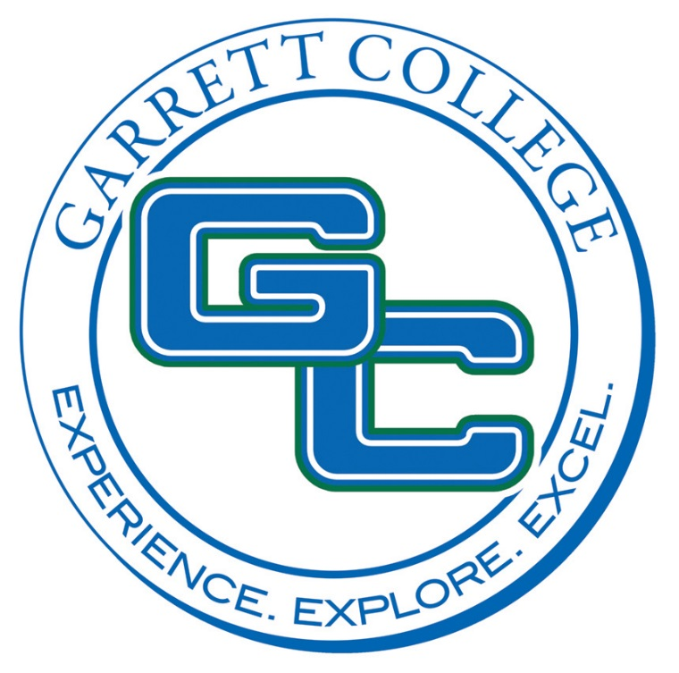

ATTACHMENT A

Mission, Vision, Values

and

Institutional Goals

**MISSION**

Garrett College recently completed a review of its mission and goals as part of the process of preparing for its upcoming self-study and reaccreditation. This review process started in January 2018 with the scheduling of a half-day event organized for the purpose of conducting a review of the College’s mission, vision, and values statements and its strategic goals. During that event, nearly all of the College’s faculty, staff, and administrators joined together in pre-assigned teams to review the College’s mission, vision, values statements, and strategic goals to recommend changes, if needed. The recommendations coming out of that process were then reviewed (and in some cases modified) by the Executive and College Councils before going to the Board of Trustees for final review and approval.

As a result of this process, some changes to the College’s mission statement were made. The revised mission statement, which was approved by the Garrett College Board of Trustees at its April 17, 2018 meeting, appears below with the added wording shown in italics.

**Garrett College provides an accessible, quality, *and comprehensive educational experience* in a supportive environment to a diverse student population *in both traditional and non-traditional settings*. We offer associate degrees and certificate programs as well as continuing education to meet the transfer, career, workforce development, and lifelong learning needs of our students and the community.  We are committed to the ongoing development of engaging, innovative, and sustainable curricula, programs, and initiatives that are responsive to a changing world.  *The College respects and cares for students as individuals and as members of diverse groups, and supports their aspirations for a better life*.**

The addition of “*comprehensive educational experience*” and “*in traditional and non-traditional settings*” in the first sentence better describes the scope of the College’s mission and emphasizes its flexibility. The addition of a new concluding sentence, “*The College respects and cares for students as individuals and as members of diverse groups, and supports their aspirations for a better life.*” reinforces and better describes Garrett College’s commitment to the success and well-being of its students.

The mission review process also resulted in revisions to portions of the College’s vision and values statements.

**VISION**

Garrett College will be a gateway where...

* We are the college of choice for students seeking a quality educational experience.
* Academic excellence and scholarly achievement will be our hallmark.
* An engaged faculty and staff are committed to students’ success and real-world preparedness.
* The campus strives to reflect the diversity of the world.
* We exemplify integrity and strong ethical principles.
* We identify, prepare, and adapt to a changing world.
* The needs of local and regional economic development shape programs and services.

**VALUES**

Garrett College believes that every human being is entitled to dignity, worth, respect, and the opportunity to learn. Therefore, Garrett College commits to…

1. **The inherent value of learning by:**

* Encouraging a culture of appreciation for the power of knowledge;
* Designing and advancing a curriculum of excellence for student mastery and success;
* Promoting ageless, life-long learning;
* Providing open access to programs and services.

1. **The inherent value of the Garrett College community by:**

* Sustaining a college focused on student learning and success;
* Fostering innovation and creativity;
* Embracing the concept of the power of people working together in the free exchange of ideas, including respectful disagreement;
* Vesting individuals with the authority and responsibility to participate in shared governance.

1. **The inherent value of the Garrett County community, the surrounding region and the global community by:**

* Recognizing diversity of people, along with their differing points of view;
* Fostering a sense of belonging;
* Facilitating an understanding of other cultures and beliefs in order to achieve a high level of cultural competence;
* Understanding the intrinsic value of our unique surroundings and of our cultural and artistic heritage;
* Providing opportunities for community awareness;
* Seeking an approach that balances preservation and progress;
* Contributing to the quality of life, economic and cultural vitality, awareness of local issues, and promotion of social justice;
* Promoting environmental awareness and serving as stewards of our environment.

**INSTITUTIONAL GOALS**

Garrett College has established six Institutional Goals that it considers fundamental and indeed critical to the accomplishment of its Mission and Vision:

***Accessibility*:** Make higher education accessible to a diverse student population through appropriate admissions practices, active recruitment of a diverse student body, affordable tuition and fees, financial aid and scholarship assistance, developmental studies for students who are under-prepared for college-level work, student support services, and delivery of courses at times and via media that are responsive to student needs.

***Student Satisfaction and Success*:**Create and sustain a supportive learning environment that encourages student growth and achievement through appropriate advising and career counseling, transfer and career preparation programs, experiential learning opportunities, and curricular as well as extra-curricular activities that encourage student engagement and responsibility.

***Educational Effectiveness*:** Ensure, through an emphasis on teaching excellence, that graduating students are able to demonstrate mastery with respect to oral and written communications skills, information literacy, critical reasoning and analysis, quantitative reasoning, scientific literacy, and information management; that they have achieved the requisite levels of academic and technical proficiency in their major; and that, through activities focusing on diversity and cultural awareness, they are adequately prepared to live and work in a global society comprised of diverse cultures and beliefs.

***Workforce Development*:**Support the economic development of Garrett County and the surrounding region by creating a skilled workforce through credit programs, as well as non-credit job readiness and workforce preparation courses; Garrett College will also be the provider of choice for affordable contract and customized training in response to the emerging needs of new and growing businesses.

***Community Service*:** Serve, within the scope of available resources, the specific needs of the community through partnerships with local government, businesses, community and arts organizations, schools, and non-profit agencies; and by providing continuing education courses for personal enrichment, lifelong learning, and community need.

***Effective Use of Financial, Human, and Physical Resources:*** Ensure, through the application of “best practices,” that financial, human, and physical resources are managed effectively and efficiently for optimal results.



ATTACHMENT B

2018

CC TABLES

ATTACHMENT C

FACILITIES RENEWAL PLAN